Case Diagram
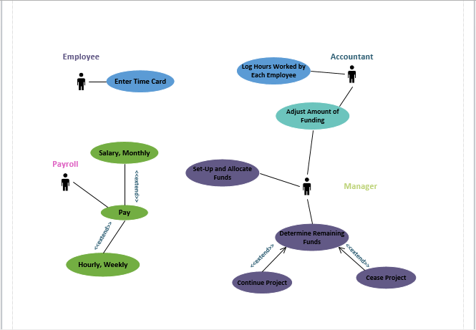
This Case Diagram shows each individual employee and their basic job requirements. The Employee enters the timecard. The Payroll Clerk pays the Employees either their Salary or Hourly pay. The Accountant logs in hours worked by the Employees and adjusts amount of funding for any projects. The Manager also adjusts the amount of funding along with setting-up and allocate funds, determine remaining funds, and decide whether to continue the project or not.

Activity Diagram
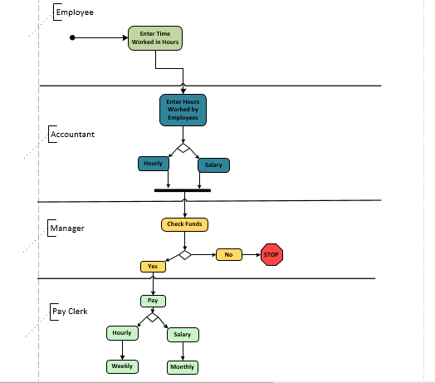
The Activity Diagram is set-up so that the common functions are defined and included in multiple activities. It shows the project set up and funds allocation activity, the timecard entry activity, the project accounting activity, and the payroll activity, all carried out by an employee and then extended out to specific job titles.

Class Diagram
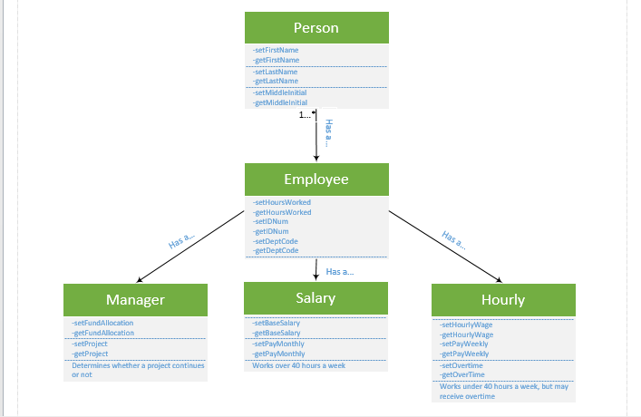
The Class Diagram has different classes for Employee, SalariedEmployee, and HourlyEmployee. There’s also a Manager class because it has several similarities in relation to all the other classes. Each class branches from a single Person branch which has both private and public initializers for their names and then flows down to Employee where the HoursWorked, IDNumbers, and DeptCode functions are located. It then branches into Manager, SalaryEmployee, and HourlyEmployee classes where each has a specific function which is suited for their class.

